STYLE GUIDE FOR SUBMISSIONS
TO THE JOURNAL SHAGI / STEPS

1. Length of submissions
Research articles — Research articles — up to 1 “author’s sheet” (= 40,000 characters, including spaces, notes, and reference-bibliographical apparatus, but excluding the annotations, key-words and bibliography). If the Editorial Team agrees, an increase in length may be allowed.
Short communications — up to 0.2 “author’s sheet” (= 8,000 characters).
Materials (publications, translations etc.) — no length limit set, but must be discussed in advance with the Editorial Team.
Reviews, chronicle — length is not predetermined.
Varia (letters to the Editors, polemics, jubilee essays, necrology, etc.) — length is not predetermined.
Illustrations for the articles, such as maps, charts, and graphs, must be forwarded to the Editorial Team as separate .JPG, .JPEG or .TIFF files; titles for the illustrations should be attached.
If a publication includes special characters, a version of the file in .PDF format must be attached.

2. General principles
1. While some Latin abbreviations are permitted: i. e. (that is), etc. (et cetera), e. g. (for example), they should be used primarily within parentheses. Outside of parentheses, they should be spelled out and should appear in the language of the submission.
“for example”, “and others”, “that is”
2. In English-language submissions, avoid using ibid. and op. cit.; follow the conventions for in-text citations.
3. Both A.D. / B.C., and CE=of the Common Era / BCE = before the Common Era, may be used with dates; A. H. = anno Hegirae may also be used where appropriate.
4. An en-dash — not a hyphen! — is used to represent a span or range of numbers, dates, or time. There should be no space between the en-dash and the adjacent material. If decades are identified by their century, numerals are used:
the 1960s and the 1990s.
No apostrophe is used between the numeral and the s.

3. Citing scholarly/scientific literature
The journal requires in-text citation of scholarly/scientific literature, using the Author-Date system: [Youngblood 2007: 51; Kosterina 1962: 40; Кронгауз 2014: 91]. Within the body of the submission, Russian names and names in other languages using Cyrillic are given in transliteration, based on the simplified Library of Congress system; however, in some case, well-known personal names may be given in their commonly accepted English form. Thus,
“ As Lev Trotsky proposed…”, “In Dostoevsky’s novel The Idiot…”
Two lists, “Literature” and “References” accompany the body of the article. If the paper doesn’t cite literature in languages using Cyrillic, the “Literature” section is not necessary. The information in each list is the same, but the entries are organized in accordance with different sets of rules.

3.1 The “Literature” section
Entries in the original Russian and other languages employing Cyrillic, as well as entries from other languages transliterated into Cyrillic, precede entries in Latin-based languages. Within each of these two groups, entries are alphabetized.
a) for monographs: author(s) — italicized; title; editor, translator, etc; place of publication, publisher, year of publication.
Хальбвакс 2007 — Хальбвакс М. Социальные рамки памяти / Пер. с фр. и вступ. ст. С. Н. Зенкина. М.: Нов. изд-во, 2007.
Oberdorfer 1998 — Oberdorfer D. From the Cold War to a New Era. Baltimore: Johns Hopkins Univ. Press, 1998.
b) for articles in collective monographs or other edited volumes: author(s) — italicized; title; complete title of collection; editor(s) or compiler(s), place of publication; publisher; year of publication; pages.
Кронгауз 2014 — Кронгауз М. А. Мем в русскоязычном интернете: опыт деконструкции // Русский язык и новые технологии / Cост. Г. Ч. Гусейнов. М.: Нов. лит. обозрение, 2014. C. 87–95.
Faubert 2015 — Faubert M. Romantic suicide, contagion, and Rousseau’s Julie // Romanticism, Rousseau, Switzerland: New prospects / Ed. by A. Esterhammer, D. Piccitto, P. Η. Vincent. Basingstoke; New York: Palgrave Macmillan, 2015. P. 38–53.
с) for articles in journals and other serial publications: author(s) — italicized; title; complete title of journal or other serial; year of publication; number / issue; pages. In those cases where a journal is numbered continuously, the volume/issue are listed prior to the year of publication.
Гродецкая 2013 — Гродецкая А. Г. Реминисценции «Новой Элоизы» в финальных главах «Обломова» и «Что делать?» (еще раз о «тоске» Ольги Ильинской в «крымской» главе романа Гончарова) // Филологические записки: Вестник литературоведения и языкознания. Вып. 31. Воронеж: Изд.-полиграф. центр «Научная книга»; Воронеж. гос. ун-т, 2013. С. 39–49.
Ryan 2013 — Ryan M.-L. Transmedial storytelling and transfictionality // Poetics Today. Vol. 34. No. 3. 2013. P. 361–388.
d) for electronic publications: full publication data and, following “URL:”, the web-link.
Alejandro 2010 — Alejandro J. Journalism in the age of social media: Fellowship paper / Reuters Institute for the Study of Journalism; Oxford University. 2010. URL: https://reutersinstitute.politics.ox.ac.uk/sites/default/files/Journalism%20in%20the%20Age%20of%20Social%20Media.pdf.
Jenkins 2010 — Jenkins H. Transmedia education: 7 principles revisited // Confessions of an Aca-Fan: The official weblog of Henry Jenkins. 2010. June 21. URL: http://henryjenkins.org/2010/06/transmedia_education_the_7_pri.html.
We ask the authors not to use hyperlinks, when citing electronic publications.
Entries in languages using alphabets other than Latin, Greek, or Cyrillic are transliterated in accordance with current standards.
Кобаяси 2004 — Кобаяси Наоки. «Сясэкисю:»-то Сё:току-тайси // Нимбун кэнкю:. T. 55. 2004. С. 13–21.
‘Aṭṭar 1998 — ‘Aṭṭar Farīd al-Dīn. Manṭiq at-ṭayr / Taṣḥīḥ va šarḥ: Kāżim Dizfulian. Tihrān: Tilāyia, 1378/1998.

3.2 The “References” section
The “References” list adheres to the style developed by the American Psychological Association (APA). All entries in this section must be in Latin script; in the case of languages employing scripts other than Latin, transliteration must be used. Literature in Russian and other Cyrillic-based languages is transliterated in accordance with the simplified Library of Congress system (without diacritics). See the example of the automatic transliteration via http://www.convertcyrillic.com/#/:
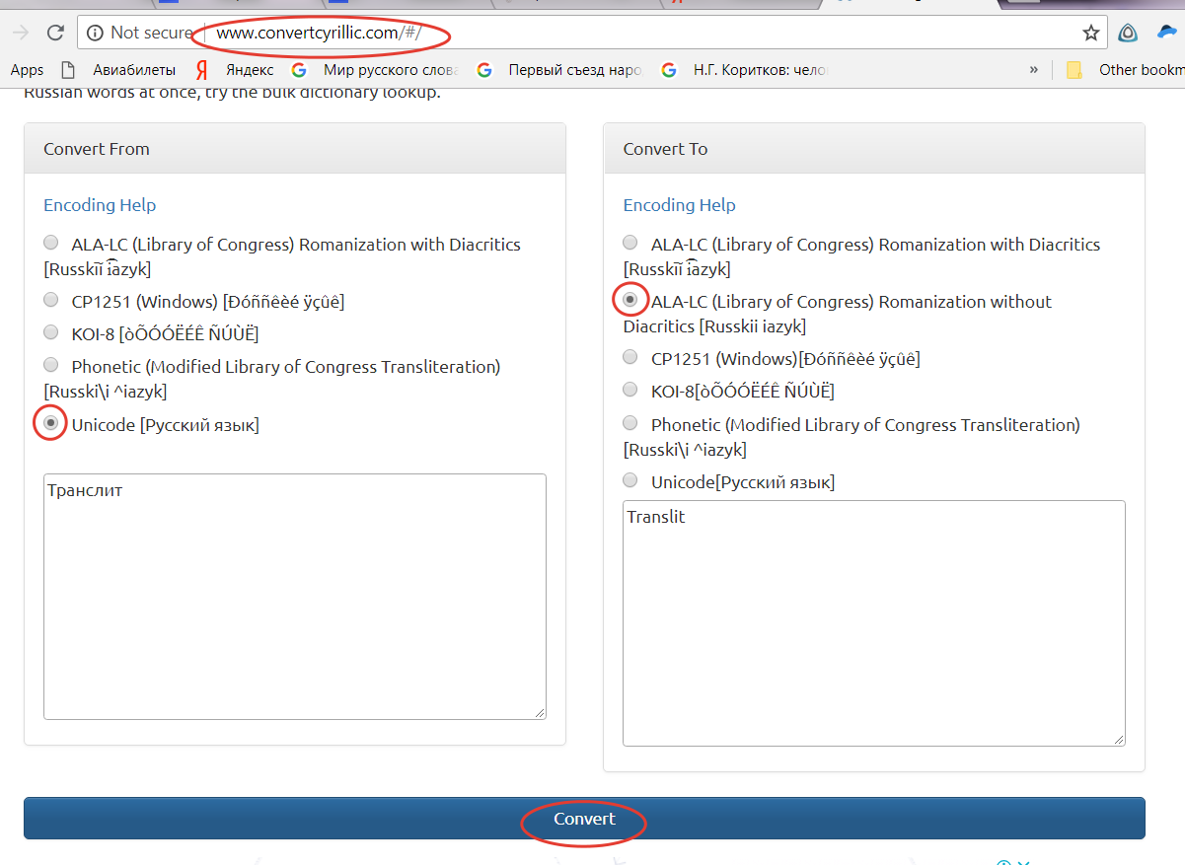
All entries are arranged in a single file in alphabetical order of English.
In transliterated entries, each key element (title of article or monograph, title of journal or edited volume) is followed by a translation into English, enclosed in square brackets. Where an English-language version of the title of a journal or other type publication in Russian or another language already exists, that version must be used.
For all entries other than those published in English, the language of publication is indicated at the end of the entry.
a) monograph: Author(s) (Last name, Initials) Year of publication (in parentheses). Title of work — italicized); first word of title and first word of subtitle, if present, capitalized, as well as any proper nouns. Place of publication: Publisher.
Dunning, Ch. S. L. (2001). Russia’s first civil war: The Time of Troubles and the founding of the Romanov dynasty. University Park, PA: The Pennsylvania State Univ. Press.
‘Aṭṭar Farīd al-Dīn (1378/1998). Manṭiq at-ṭayr [Bird Parliament] (Kāżim Dizfulian, Compl. and Comment.). Tihrān: Tilāyia. (In Persian).
Ribera, L. (1964). Misalito Regina, para jóvenes. Barcelona: Regina. (In Spanish).
b) edited book: Format as above, beginning with the name(s) of the editor(s)
Bergin, O., Best, R. I. (Eds.) (1929). Lebor na hUidre: Book of the Dun Cow. Dublin: Hodges, Figgis.
Kurdiumova, T. F. (Ed.). (1991). Programmy po literature dlia srednikh obshcheobrazovatel’nykh uchebnykh zavedenii [Curricula for literature lessons for secondary schools]. Moscow: Prosveshchenie. (In Russian).
c) article in journal: Author(s) Year of publication (in parentheses). Title of article. Title of journal — italicized, capital letters, Volume number (italicized), issue number in parentheses (not italicized), page range.
In the case of a journal where a volume number is not indicated, the year of publication should be used in its place.
De Souza e Silva, A. (2006). From cyber to hybrid: Mobile technologies as interfaces of hybrid spaces. Space & Culture, 9(3), 261–278.
Chaikovskii, M. S. (1891). Zapiski [Notes]. Kievskaia starina [Kievan antiquities], 1891(10), 98–107 (In Russian).
d) article or chapter in edited book: Author(s) Year of publication (in parentheses). Title of article or chapter. “In”, followed by the names of volume editors (Initial 1. Initial 2. Last name) (Ed. or Eds.), Title of edited volume — italicized, page range, place of publication: publisher.
Kroll, J. F., Dussias, P. E. (2013). The comprehension of words and sentences in two languages. In T. Bhatia, W. Ritchie (Eds.). The Handbook of bilingualism and multilingualism, 2nd ed., 216–243. Malden, MA: Wiley-Blackwell.
Paunova, E. V. (2001). Obmiraniia u lipovan [Times of temporary death among the Lipovans]. In O. B. Khristoforova (Compl.), S. Iu. Nekliudov (Ed.). Sny i videniia v narodnoi kul’ture. Mifologicheskii, religiozno-misticheskii i kul’turno-psikhologicheskie aspekty [Dreams and visions in popular culture. Mythological, religious and mystical, cultural and psychological aspects], 181–197. Moscow: RGGU. (In Russian).
Vasil’eva, T. V. (2008). O geroe “Eneidy” [About the hero of the Aeneid]. In T. V. Vasil’eva. Poetika antichnoi filosofii [Poetics of ancient philosophy], 681–686. Moscow: Akademicheskii Proekt; Triksta. (In Russian).
In the case of translated scholarly literature, information about the original source of the translation, in square brackets, follows the title.
Khal’bvaks, M. (2007). Sotsial’nye ramki pamiati [The social frameworks of memory] (Trans. from: Halbwachs, M. (1952). Les cadres sociaux de la mémoire. Paris: Presses Universitaires de France). Moscow: Novoe izdatel’stvo. (In Russian).
Krom, M. M. (2010). “Vdovstvuiushchee tsarstvo”: Politicheskii krizis v Rossii 30–40-kh godov XVI veka. [The “widowed kingdom”: The political crisis in Russia of the 1530–40s]. Moscow: Novoe literaturnoe obozrenie. (In Russian).
In the case of electronic references, publication data is followed by the words “Retrieved from” and the web-link.
Allen, J. P. (2013). A New concordance of the Pyramid Texts: 5th and 6th Dynasty. [Ν. p.]: Brown Univ. Retrieved from https://www.dropbox.com/sh/0xo88uy04urnz0v/o16_ojF8f_.
Merz, J. (2002). Time use research and time use data — actual topics and new frontiers. FFB Discussion Paper, no. 32. Retrieved from http://www.leuphana.de/fileadmin/user_upload/
Forschungseinrichtungen/ffb/files/publikationen/diskussion/DP_32_time_use_db.pdf.
U predatelei ne bylo shansov vyzhit’ [Traitors had no chance to survive] (2013, January 17). Komsomol’skaia Pravda [Komsomol Pravda]. Retrieved from http://www.kp.ru/daily/26016.3/2938453. (In Russian).

Abbreviations used in “References” list
The following abbreviations are used: Ed., Eds. = editor(s); Compl. = compiler, compiled by; Trans. = translator(s), translated by; Univ. = university
The place of publication and the publisher’s name are given in full. Thus, if an entry in the “Literature” section contains: M.: Nov. lit. obozrenie, then in the “References” section the corresponding entry should state: Moscow: Novoe literaturnoe obozrenie.

4. Treatment of sources
In case of multiplicity of non-academic sources (fiction, media publications ets.), they may also be included in the list “Sources”, which is not duplicated in “References”.
If an article is based on archival materials, these should be enumerated in a separate section, “Archival Sources”, prior to the “Literature” section, and not duplicated in “References”.
In the text of the article, archival documents may be cited as follows: [Постановление 1981], [Кривой 1938. Л. 2], [Sederholm 1826a], [Gästebuch (2)]. The list of sources will contain these entries:
Постановление 1981 — Постановление совета Министров РСФСР от 30.11.81 «Об улучшении практики организации художественной самодеятельности в РСФСР» (Государственный архив Российской Федерации. Ф. А-259. Оп. 1. Д. 4240. Л. 32–35).
Кривой 1938 — Кривой — Алексееву. Докладная записка. [1938 г.] (ПермГАНИ. Ф. 105. Оп. 5. Д. 95. Л. 1–9).
Sederholm 1826a — Sederholm K. Brief an Cotta, 31. März 1826 (Deutsches Literaturarchiv Marbach, Cotta Br.).
Gästebuch — Gästebuch Gedenkstätte der Befreiung auf den Seelower Höhen. Bd. 2, 4, 5 (Archiv der Gedenkstätte / Museum Seelower Höhen).
Abbreviations used in this section are listed and explicated in a separate section.
Web-based sources may be cited by name and date of publication (in citing material from social media and forums, the nickname of the author of an entry and other relevant information may be included). If necessary, and if news sources are involved, a list of “Internet Sources” may be created (it is not duplicated in “References”). Some examples:
Захаров 2003 — Захаров Д. Актуальные вопросы антинаркотической пропаганды // Нет наркотикам: Информационно-публицистический ресурс. 2003. 23 окт. URL: http://www.narkotiki.ru/5_5623.htm.
Питонов 2013 — Питонов А. Сюжет песни о Донбассе Доризо подсказал муж Клары Лучко // Donbass.Ua. 2013. 22 окт. URL: http://donbass.ua/news/articles/gzl/2013/10/22/sjuzhet-pesni-o-donbasse-dorizo-podskazal-muzh-klary-luchko.html.
Серебрякова 2016 — Серебрякова В. Масленица на лабутенах: [Запись в соц. сети «ВКонтакте»]. 2016. 31 марта. URL: https://vk.com/vserebryakova89?z=photo225629103_411343287%2Fwall225629103_450.

5. Handling of field materials
When citing notes on field research, a “List of Informants” should be created. They may be identified by initials (for example, [NN], [ЗЗА]), by name, [Черных], or by number (for example, [Инф. 1].
NN — муж.; интервью 12 нояб. 2012 г., интервьюер З. С. Васильева (2012а); 27 нояб. 2012 г., интервьюер Р. И. Хандожко (2012b).
ЗЗА — Загорская Зиновея Антоновна, 1925 г. р., с. Муравлёвка Измаильского р-на Одесской обл., Украина.
Черных Н. С. — интервью 7 дек. 2012 г., интервьюер Р. И. Хандожко.
Инф. 1 — жен., 35 лет, Москва.

6. Author information, abstract, keywords and acknowledgements
Each article is accompanied by the following supplementary materials:
1. Information about the author
Last Name, First Name, Middle Name(s), complete, in Russian and transliterated; non-Cyrillic names are given in standard Russian transcription and in the original language. Highest degree, position, employer (in full), postal address of employer, including the postal index, work phone number, e-mail address.
Information about the author is formatted as follows, in Russian and in English:
First name, Middle name, Last name
ORCID (for example: 0000-1111-2345-6789)
academic degree (for example: Cand. Sci. (Philology), or: PhD)
position (for example: Assistant Professor)
affiliation (with the title of organization, department, faculty etc.) (for example: Centre for Typological and Semiotic Folklore Studies, Russian State University for the Humanities)
full postal address (with index) (for example: Russia, 125993, GSP-3, Moscow, Miusskaya Sq., 6)
office phone (for example: +7 (499) 973-43-54)
e-mail

2. If the article is in Russian, the title translated into English; if the article is in English, the title translated into Russian. In either case, the translation should be informative and reflect the contents of the article.
3. Keywords in Russian and English (from 9 to 12; not required for reviews and scholarly chronicle entries).
4. Abstracts in both Russian and English. The English-language abstract of an article may be from 200 to 250 words in length, the Russian-language abstract may be from 100 to 150 words in length. The abstract should set out the main ideas, the goals and results of the research presented in the article. Abstracts of scholarly chronicle reports may be shorter.
A book review does not require an abstract; instead, it includes a complete bibliographic description of the work(s) being reviewed — in Russian, following the rules set out in the “Literature” section, and in transliteration, following the APA format, as set out in the “References” section. In the case of a non-Russian work under review, a bibliographic description in both formats also will be provided.
Рецензия на: Настройка языка: управление коммуникациями на постсоветском пространстве: Коллективная монография / Под ред. Е. Г. Лапиной-Кратасюк, О. В. Мороз, Е. Г. Ним. — М.: Нов. лит. обозрение, 2016. — 448 с. — (Научная библиотека. Научное приложение; Вып. 153).
A review of: Lapina-Kratasyuk, E. G., Moroz, O. V., Nim, E. G. (Eds.) (2016). Nastroika iazyka: upravlenie kommunikatsiiami na postsovetskom prostranstve: Kollektivnaia monografiia [Adjusting language: Managing communications in post-Soviet space. A collective monograph]. Moscow: Novoe literaturnoe obozrenie 448 p. (In Russian).
An example of an English-language abstract of a scholarly chronicle report:
Abstract. The short paper contains a review of a conference, “Local branding: Between marketing and folklore”, held in Moscow (The Moscow School of Social and Economic Sciences) on December 2–3, 2016.
5. Acknowledgements (In Russian and English).

